Mohammad Akbari

Abstract

Coronavirus disease 2019 (COVID-19) is a [contagious disease](https://en.wikipedia.org/wiki/Contagious_disease) caused by the [coronavirus](https://en.wikipedia.org/wiki/Coronavirus) [SARS-CoV-2](https://en.wikipedia.org/wiki/SARS-CoV-2). The first known case was [identified in Wuhan](https://en.wikipedia.org/wiki/COVID-19_pandemic_in_Hubei), China, in December 2019. Most scientists believe the SARS-CoV-2 virus entered into human populations through natural [zoonosis](https://en.wikipedia.org/wiki/Zoonosis), similar to the [SARS-CoV-1](https://en.wikipedia.org/wiki/SARS-CoV-1) and [MERS-CoV](https://en.wikipedia.org/wiki/MERS-CoV) outbreaks, and consistent with other pandemics in human history. The diagnosis is made by a positive PCR test, which is highly specific. CT has a higher sensitivity but lower specificity and can play a role in the diagnosis and treatment of the disease.  
In this article we will describe the role of imaging.

Keywords: CT, COVID-19, pneumonia, Deep Learning , Medical image processing

1.Introduction

Coronavirus disease (COVID-19) is an infectious disease caused by the SARS-CoV-2 virus.

Most people infected with the virus will experience mild to moderate respiratory illness and recover without requiring special treatment. However, some will become seriously ill and require medical attention. Older people and those with underlying medical conditions like cardiovascular disease, diabetes, chronic respiratory disease, or cancer are more likely to develop serious illness. Anyone can get sick with COVID-19 and become seriously ill or die at any age.

The best way to prevent and slow down transmission is to be well informed about the disease and how the virus spreads. Protect yourself and others from infection by staying at least 1 metre apart from others, wearing a properly fitted mask, and washing your hands or using an alcohol-based rub frequently. Get vaccinated when it’s your turn and follow local guidance.

The virus can spread from an infected person’s mouth or nose in small liquid particles when they cough, sneeze, speak, sing or breathe. These particles range from larger respiratory droplets to smaller aerosols. It is important to practice respiratory etiquette, for example by coughing into a flexed elbow, and to stay home and self-isolate until you recover if you feel unwell.

To prevent infection and to slow transmission of COVID-19, do the following:

* Get vaccinated when a vaccine is available to you.
* Stay at least 1 metre apart from others, even if they don’t appear to be sick.
* Wear a properly fitted mask when physical distancing is not possible or when in poorly ventilated settings.
* Choose open, well-ventilated spaces over closed ones. Open a window if indoors.
* Wash your hands regularly with soap and water or clean them with alcohol-based hand rub.
* Cover your mouth and nose when coughing or sneezing.
* If you feel unwell, stay home and self-isolate until you recover.

COVID-19 affects different people in different ways. Most infected people will develop mild to moderate illness and recover without hospitalization.

**Most common symptoms:**

* fever
* cough
* tiredness
* loss of taste or smell.

**Less common symptoms:**

* sore throat
* headache
* aches and pains
* diarrhoea
* a rash on skin, or discolouration of fingers or toes
* red or irritated eyes.

**Serious symptoms:**

* difficulty breathing or shortness of breath
* loss of speech or mobility, or confusion
* chest pain.

Seek immediate medical attention if you have serious symptoms.  Always call before visiting your doctor or health facility.

People with mild symptoms who are otherwise healthy should manage their symptoms at home.

On average it takes 5–6 days from when someone is infected with the virus for symptoms to show, however it can take up to 14 days.

2. Literature review

Deep learning performs a vital role in the biomedical image classification area due to its unique feature extraction and pattern recognition ability. In order to detect COVID-19 from CT scans and X-ray images, a convolutional neural network (CNN) has been the preferred approach.

Apostolopoulos et al. applied an evolutionary neural network for robust differentiation and automatic detection of COVID-19 with both typical pneumonias and COVID-19-induced pneumonia . Chen et al. developed a multilayer deep learning-based model that has success fully detected COVID-19 with high sensitivity in a shorter time from chest X-ray images . Khan et al. proposed a framework employing the deep learning architecture for COVID-19 detection using normal, bacterial and viral pneumonia cases . Sahinbas and Catak pre sented a comparative analysis of performance measures using VGG16, VGG19, ResNet, DenseNet and InceptionV3 models on chest X-ray images . Punn and Agarwal exhibited great sensitivity and precision on X-ray images using ResNet, InceptionV3, Inception-ResNet models for COVID-19 detection . Hemdan et al. success fully used advanced deep learning models for COVID-19 diagnosis in X-ray images and pro posed a highly efficient COVIDX-Net model containing seven individual CNN models . Maghdid et al. presented a deep neural network-based method coupled with a transfer learning strategy for automatic detection of COVID-19 pneumonia . Ghoshal and Tucker studied the uncertainty in deep learning solutions for COVID-19 detection in X-ray images using Drop Weights based Bayesian Convolutional Neural Networks (BCNN). Farooq and Hafeez suggested COVID-ResNet, an efficient fine-tuned and pre-trained ResNet-50 architecture for the early detection of COVID-19 pneumonia screening . The COVID-ResNet framework achieved an accuracy of 96.23% on a multi-class classification on COVID-19 infection dataset. Chen et al. proposed an advanced Residual Attention U-Net for the automated multi-class segmentation procedure on COVID-19-related pneumonia applying CT images . Narinet al. employed ResNet-50, InceptionV3 and Inception-ResNetV2 for 2-class classification and achieved the best accuracy of 98% with a pre-trained ResNet-50 model . The following sections discuss the detailed structure of the proposed CAD scheme in this paper and the impact of the algorithms on COVID-19 detection. The majority of these works achieved good results on either X-ray images or CT scans indi vidually, but do not show a holistic comparison between the two. It is important to know which modalities perform best with which deep learning architecture. Additionally, we aimed to test certain models that have not been tested before, such as Xception.

3.CT SCAN

 computed tomography scan (CT scan; formerly called computed axial tomography scan or CAT scan) is a [medical imaging](https://en.wikipedia.org/wiki/Medical_imaging) technique used to obtain detailed internal images of the body. The personnel that perform CT scans are called [radiographers](https://en.wikipedia.org/wiki/Radiographer) or radiology technologists.

CT scanners use a rotating [X-ray tube](https://en.wikipedia.org/wiki/X-ray_tube) and a row of detectors placed in a [gantry](https://en.wikipedia.org/wiki/Gantry_(medical)) to measure X-ray [attenuations](https://en.wikipedia.org/wiki/Attenuation#Radiography) by different tissues inside the body. The multiple [X-ray](https://en.wikipedia.org/wiki/X-ray) measurements taken from different angles are then processed on a computer using [tomographic reconstruction](https://en.wikipedia.org/wiki/Tomographic_reconstruction) algorithms to produce [tomographic](https://en.wikipedia.org/wiki/Tomography) (cross-sectional) images (virtual "slices") of a body. CT scans can be used in patients with metallic implants or pacemakers, for whom [magnetic resonance imaging](https://en.wikipedia.org/wiki/Magnetic_resonance_imaging) (MRI) is [contraindicated](https://en.wikipedia.org/wiki/Contraindication). Since its development in the 1970s, CT scanning has proven to be a versatile imaging technique. While CT is most prominently used in [medical diagnosis](https://en.wikipedia.org/wiki/Medical_diagnosis), it can also be used to form images of non-living objects. The 1979 [Nobel Prize in Physiology or Medicine](https://en.wikipedia.org/wiki/Nobel_Prize_in_Physiology_or_Medicine) was awarded jointly to South African-American physicist [Allan MacLeod Cormack](https://en.wikipedia.org/wiki/Allan_MacLeod_Cormack) and British electrical engineer [Godfrey Hounsfield](https://en.wikipedia.org/wiki/Godfrey_Hounsfield) "for the development of computer-assisted tomography".

Lungs

A CT scan can be used for detecting both acute and chronic changes in the [lung parenchyma](https://en.wikipedia.org/wiki/Parenchyma#Lung_parenchyma), the tissue of the [lungs](https://en.wikipedia.org/wiki/Lung). It is particularly relevant here because normal two-dimensional X-rays do not show such defects. A variety of techniques are used, depending on the suspected abnormality. For evaluation of chronic interstitial processes such as [emphysema](https://en.wikipedia.org/wiki/Pneumatosis#Lungs), and [fibrosis](https://en.wikipedia.org/wiki/Pulmonary_fibrosis), thin sections with high spatial frequency reconstructions are used; often scans are performed both on inspiration and expiration. This special technique is called [high resolution CT](https://en.wikipedia.org/wiki/High_resolution_CT) that produces a sampling of the lung, and not continuous images.

5. Dataset

CT scan images: The CTscan images dataset we used to feed our algorithm is the public covid-chestxray-dataset dataset, stored in a GitHub repository . During the first of January 2021, the dataset consisted of 746 unique CT image scans of patients. The dataset contains meta information of patient’s details and any other diseases the patient may have.etc. COVI D19-related papers from medRxiv and bioRxiv etc. were also used for gathering images for the work. It is also mentioned that this dataset is constantly updated with new images of patients. More details of the dataset can be found at . Out of the 746 images, there were 349 COVID-19 affected images and 397 non-COVID-19 images. Fig 1 shows some samples from the dataset containing positive and negative Covid19 CT scan images.

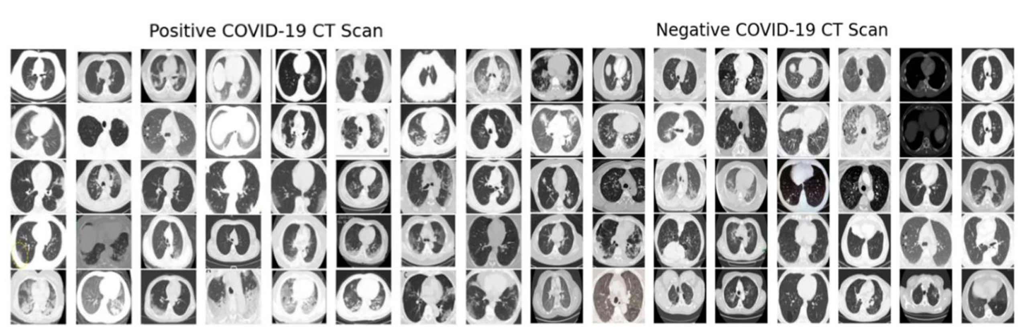

Fig 1. COVID19CTscansample.

https://doi.org/10.1371/journal.pone.0302413.g001

X-ray images: We have collected the X-ray images for our models from two different datasets. We have collected COVID-19 infected images from a publicly open GitHub repository . It consisted of chest X-ray images of patients which are positive or suspected of COVID-19 or MERS, SARS, ARDS. Some ofthe data are collected indirectly from hospitals and physicians. The second dataset we used for X-ray images is from a public Kaggle dataset from which we have collected images of normal, bacterial pneumonia and viral pneumonia infected patients. Although it contains images of COVID19 infected patients, we have only used the negative images because there was insufficient number of covid-19 images Overall, we used 930 X-ray images of Covid-19 infected patients, 880 Normal images, 650 Bacterial Pneumonia and 412 Viral Pneumonia images. Fig 2 shows some samples of positive and negative Covid-19 Xray images.

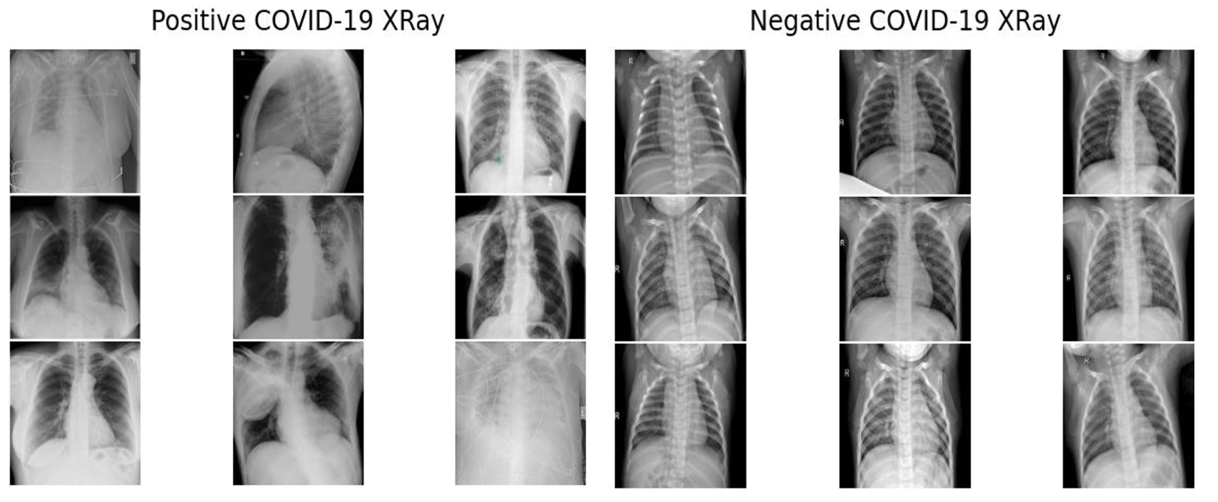

Fig 2. COVID19chest Xraysample.

https://doi.org/10.1371/journal.pone.0302413.g002

6. Deep learning models and methods

The chosen deep learning models are described in this section Inception v3: Inception V3 CNN based deep neural network with 48 hidden layers of module and primarily contains 13ⅹ3 and 5ⅹ5 convolutions . Inception v3, trained on ImageNet , could classify images into a total of 1000 categories, including keyboard, pencil, mouse, and manyother animals. The model we used was pretrained on more than one million images from the ImageNet dataset . The original layers were frozen and several additional layers were added for fine-tuning. These are shown in Fig 3.

VGG19:VGG-16has16convolutional and 3 fully connected layers. It used ReLU as the acti vation function, just like in AlexNet. VGG-16 had 138 million parameters. A deeper version, VGG-19, was also constructed along with VGG-16. The Architecture is shown in Fig 4 .

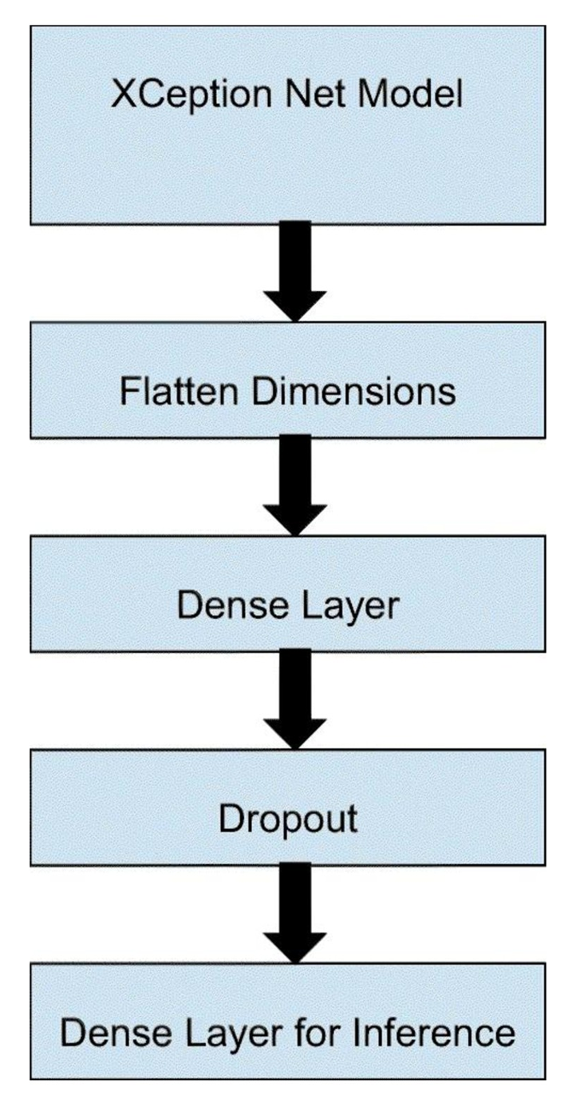

Fig 4. VGG19architecture .

https://doi.org/10.1371/journal.pone.0302413.g004

Xception: Xception has 71 hidden layers and 23 million parameters. Xception was heavily inspired by Inception-v3, albeit it replaced convolutional blocks with depth-wise separable convolutions . The architecture is given in Fig 5.

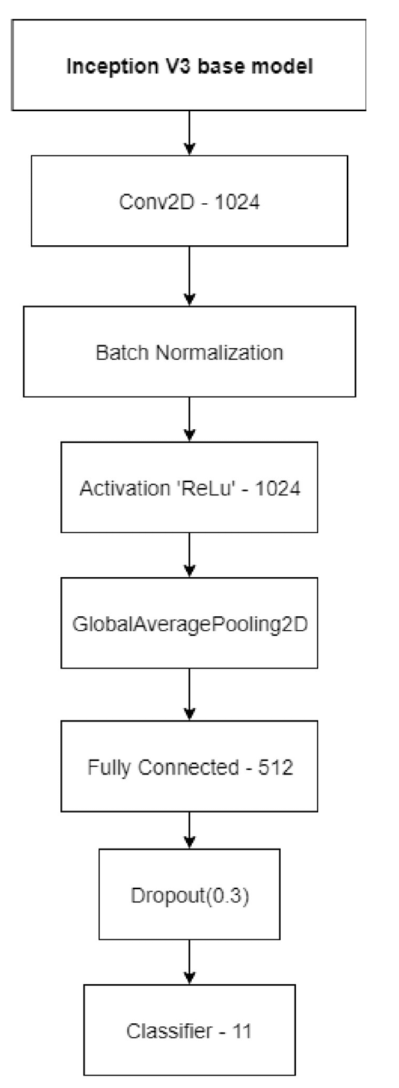

Fig 5. Xception architecture .

https://doi.org/10.1371/journal.pone.0302413.g005

ResNet-50: At 50 layers deep and featuring 25.5 million parameters, ResNet-50 was pretrained on more than a million images from the ImageNet dataset.

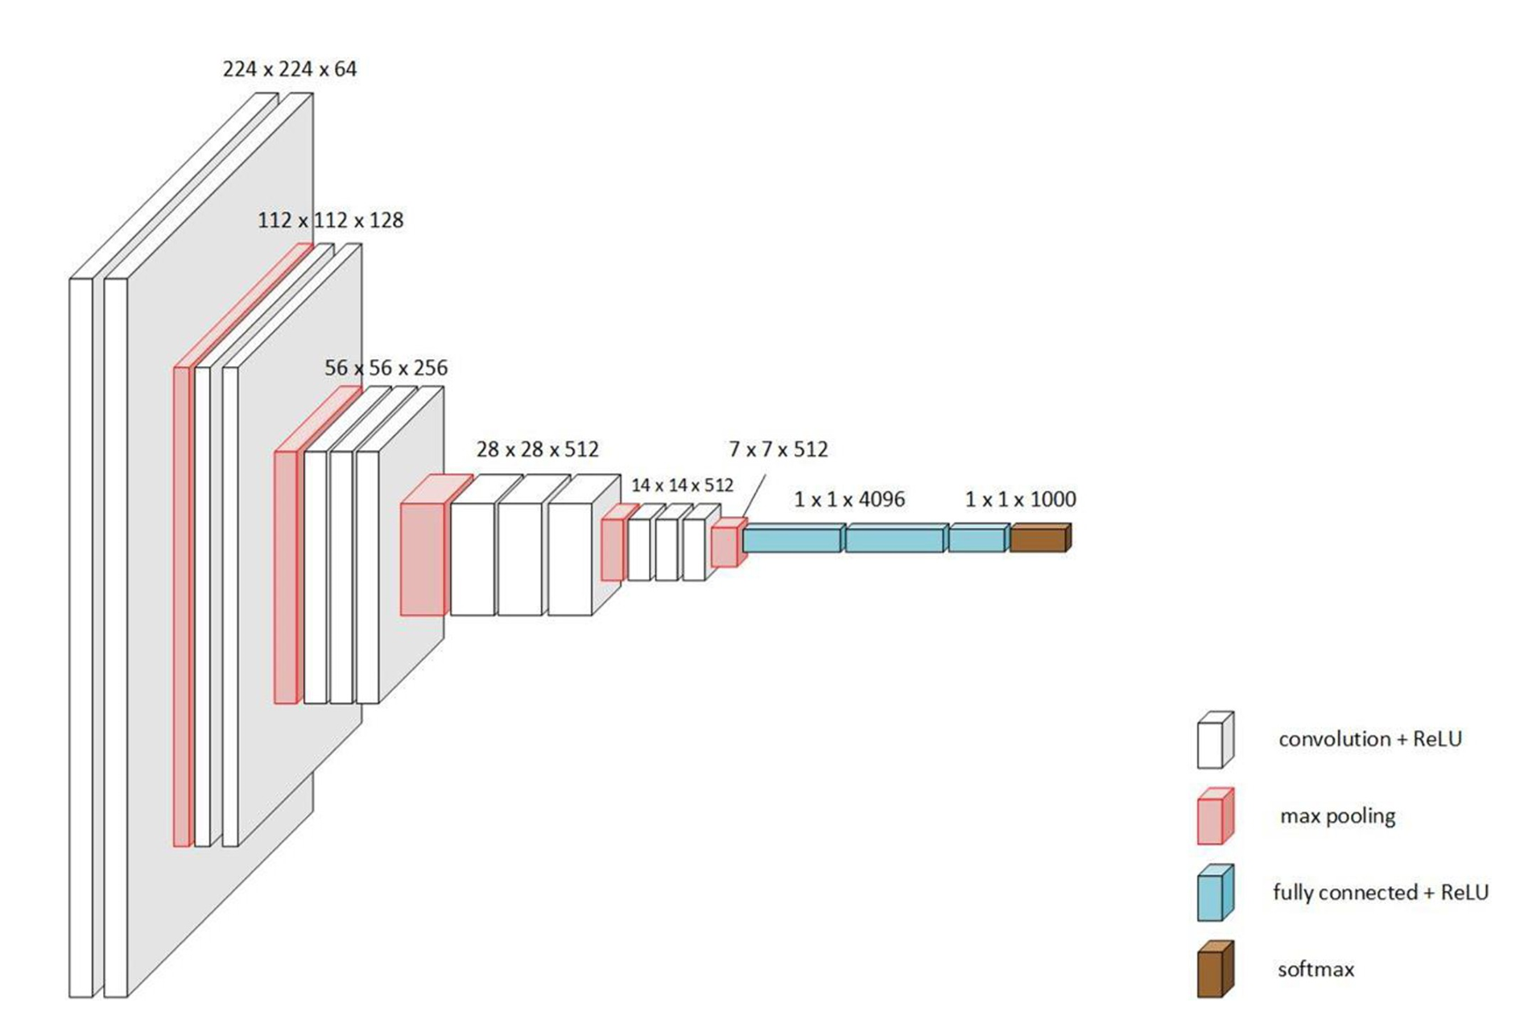

Fig 3. Inception V3 architecture .

https://doi.org/10.1371/journal.pone.0302413.g003

Ethical Statement: Confirming that all experiments/analysis were performed in accordance with relevant guidelines and regulations

5. Data preprocessing

The following subsections describe the steps we used in running our models for detecting COVID-19 using 2 types of images (CT scan and Chest Xray images). We used a similar process using InceptionV3, ResNet-50, VGG19 and Xception. Data Splitting: The dataset we have used is split into two sets, namely Train and Test. How ever, we should keep in mind that medical images are comparatively more diverse and subjec tive and so similar cases are observed in our dataset. It is expected that the deployment of the algorithm may not initially match with other images of real-world scenarios and thus we can receive images drastically different from those used in the training. Our dataset is split in the ratio of 80:20 for training and testing sets. This was randomly sampled from the dataset into the subsets.

7. Experimental section

In this study, we performed deep learning analysis on 4 different datasets. Among them two of them are CT scan and X-ray images of COVID/Non-COVID patients and other two are X-ray images of bacterial pneumonia and viral pneumonia images of normal patients. Here we deployed 4 prominent deep learning models, which are VGG-19, ResNet-50, Inception V3 and Xception. In the following section we will discuss 4 test cases highlighting key performance metrics such as confusion matrix, ROC curve, model accuracy, model loss and try to find out which model is best suited for COVID detection or normal pneumonia detection.

For each model, we used a pretrained model and added fine-tuning layers. First, we used a flatten layer to flatten the input features, and then a dropout layer to reduce overfitting. After that, we used a dense fully connected layer and a softmax output to get the final prediction. For hyperparameters, we used a cross-entropy loss and an Adam optimizer.

Case 1: CTscan Image Analysis for COVIDIdentification Wetrained the models for 500 epochs and predicted the trained models on the test set. Then weplotted the confusion matrices, ROC curves, Classification reports, Accuracy and Loss curves. Firstly, let us look at the results using the CT scan images of COVID-19 and non COVID-19 infected people.

* 1. Confusion matrix

Aconfusion matrix describes the performance of a classification model. In this chapter the True Positives are the patients who have COVID19 and are detected correctly by the algo rithm. The rows in a confusion matrix correspond to what the machine learning algorithm has predicted. In our case, one will be that the patient has COVID-19 and, the other a non COVID-19 response. The top left corner contains true positives. These are patients who have COVID-19 andare detected correctly by the algorithm. And the bottom right corner has the ’True Negatives’. These are patients who did not have COVID-19 and the algorithm correctly

identified them for not having COVID-19. The left-hand corner contains the ’False negatives’. False Negatives are when a patient has COVID-19, but the algorithm says they don’t. And the top right corner has the False positives. The false positives are patients that do not have COVID-19 but the algorithm says they do. Wetook152samples for testing. Among them, our trained model could detect 67 of the affected patients correctly. 59 unaffected patients were also detected correctly by our model. Our model misclassified 3 patients having COVID-19 as unaffected.

* 1. ROC curve

AROCcurveorreceiver operating characteristic curve is a graph that shows the efficiency of a classification model at all classification thresholds., we can see the combined ROC curves plotted in one plot and their AUCs. Along the X axis of ROC curve, False Positive Rate or FPR is represented and along Y axis True Positive Rate or TPR is represented. The ROC curve shows the trade-off between sensi tivity (or TPR) and specificity (1–FPR). Classifiers that give curves closer to the top-left corner indicate a better performance. As a baseline, a random classifier is expected to give points lying along the diagonal (FPR = TPR). The closer the curve comes to the 45-degree diagonal of the ROCspace, the less accurate the test. In the above ROC curve of the Xception model, we can see that the curve is very far away from the 45-degree diagonal of the ROC space which indicates that the curve is very accurate. The AUC also confirms our model is very accurate.

* 1. Model Accuracy

Accuracy is the number of correct predictions. We used both test and train data and calcu lated the accuracy after each epoch to form the accuracy curve. The blue line describes the training accuracy, and the yellow line describes the test accuracy. In the model accuracy curves. The test curve follows the train curve which happens in all cases therefore showing us that the model is working properly. The fluctuation in the line is due to the limited amount of data we had. However, we can see that the test curve is closer to the train curve in the Xception and VGG19 model.

iv. Computing Losses Loss is the penalty for a bad prediction. That is, loss is a number indicating how bad the model’s prediction was on a single example. If the model’s prediction is perfect, the loss is zero; otherwise, the loss is greater. In the model loss curves, we can find more about how the testing and training process is taking place, we can see both the Training loss and the Test loss curve is going down. In the end there is an unrepresentative split between train and test data. The curve is jumping up and downbecause we have limited data. The test curve should follow the train curve which hap pens in all cases therefore showing us that the model is working properly. Although there are some spikes in the curve, it is not to be considered and if we find the mean of the curve, we can see that the test curve is closer to the train curve in the Inception and Xception model

8. Experimental result and approach

SARS-CoV-2 infection was detected and classified with the proposed model using CT scan images. The infection was classified into two categories: COVID-19 and Pneumonia. The proposed model’s performance was assessed using f ivefold cross-validation for the binary class. It is well recorded that the loss values increased significantly at the beginning of training and decreased considerably. This variation occurred due to the number of images in the COVID-19 class, which was considerably lower than in the pneumonia class. However, the magnitudes of the afore mentioned rapid increases and decreases gradually declined in the latter part of the training when the proposed system repeatedly examined all the CT scan images. A three-level hierarchical procedure was performed to segment the COVID-19 CT region in images. First, iso tropic resampling was conducted on the extracted volume, which was subsequently processed using an edge-enhanc ing diffusion filter for noise suppression. Next, a modified MaxFlow or MinCut algorithm was used to segment the chest. In this algorithm, the shape representation based on the Poisson equation was used to generate chest boundary maps on 1D across-boundary CT profiles through autono mously trained KNN classifiers (K=20). To avoid errors due to image processing, all the segmentations were manually verified and corrected if required. Each lesion’s low-level image features were computed. These features were used in separately trained radial basis function SVM classifiers to obtain markings for the observation nodes. The RILML model SVM-based annotation method, which uses the SVM algorithm and linear collaborations of steerable Riesz wavelets, was compared with the proposed system to assess the projected plan’s strength in contra diction of autonomous annotations (preliminary observa tions). We extracted 2D cross-sectional images from each lesion, selected image patches arbitrarily from peripheral and internal regions, and generated feature vectors to per form the comparison . The study of specific SVM classifiers, trained on features, is useful to each concept value associated with texture and shape-related modeled value set to obtain a probability. Therefore, the SVM observations (XSVM) setting depended on the maximum probability among the related value sets, and the proposed iterative online annotation was used . The training data were divided into many groups. Ini tially, radiologists hand-labeled some CT images belonging to a group with a small amount of data. Descriptor methods were then used to extract features. Subsequently, the ML annotation model was trained as an initial model by using the aforementioned data group. This model was used to annotate infection areas in the images belonging to the following group. The radiologists performed manual checks to improve the annotation results obtained with the ML annotation model. The modified annotation outcomes were then used as new training data, and model retraining was performed with an augmented training dataset. The procedure as mentioned above resulted in a repeated increase in the training dataset’s size and the final ML model generation. In the testing phase, infected regions were annotated on new CT images by using the trained annotation model. The proposed approach performs well after 4–5 repetitions.

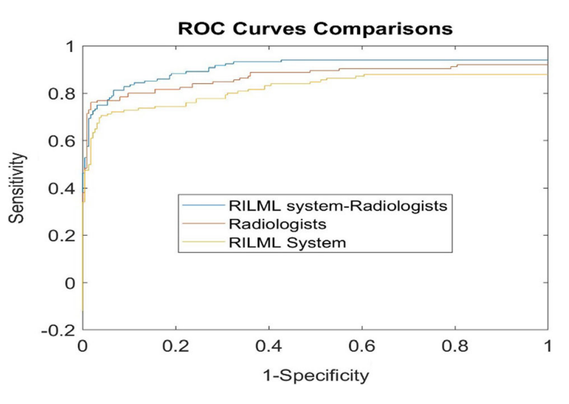

Fig 6. ComparativeROCbetweenRILML,Radiologists,andRILML withRadiologist

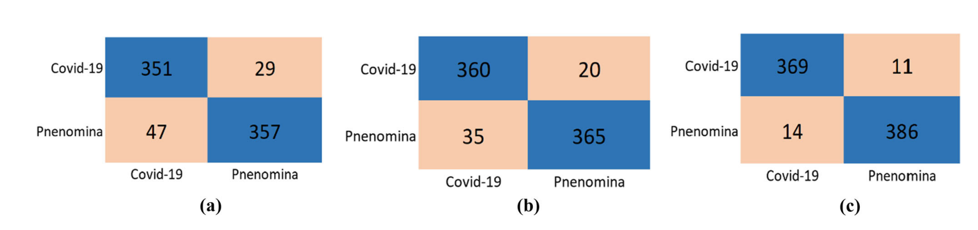

Fig. 7. ConfusionMatrixofaRILML,bRadiologist,andcRadiologist?RILML

9. DISSCUSION

From the results of research conducted to classify covid-19, pneumonia and normal lungs based on x-ray images using the Convolutional Neural Network (CNN) method, the following conclusions can be drawn: Basically the CNN algorithm is an algorithm capable of classifying objects without the need for additional feature extraction. Because the algorithm already has features of the stages or learning process. However, during the research, the amount of data held was too little and the quality of the data obtained was not good, making researchers add additional feature extraction to facilitate the algorithm in extracting features from the image to be processed. By changing the RGB image to a grayscale image, the researchers succeeded in sharpening the image to simplify the extraction process. In this method the Convolutional Neural Network method can be used to extract and differentiate x-ray image results and can produce a fairly high accuracy value with a level of 80-90%. The research conducted is still said to be not optimal. Therefore, future research is to improve the model that has been proposed with various approaches, such as proposing a fine tuning method by trying several types of optimizing variables, experimenting with more than one pre-processing technique, increasing the number of datasets used, using a preserved model, which is on CNN.